Sohal Patel

**Week 3 (The Relational Database Model)**

21. There are five attributes: EMP_NUM, EMP_LNAME, EMP_INIT, EMP_FNAME, DEPT_CODE and JOB_CODE. There are ten entities. The EMPLOYEE is the entity set. Attribute EMP_NUM is the primary key because every entity is shown in each row by the EMP_NUMs. The JOB_CODE and DEPT_CODE are the foreign keys because they are probably linked to other table describing which department they work in and a description of what they do.

22. For DIRECTOR table's the primary key is DIR_NUM and for PLAY table's the primary key is PLAY_CODE.

23. The foreign key is DIR_NUM in the PLAY table.

24.

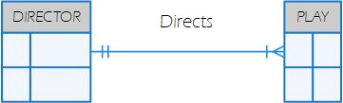

25.

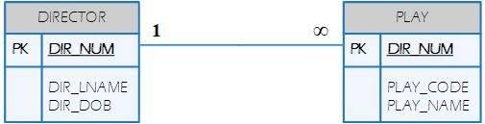

26. The PLAY table would be the reason for the proper index table. The index key would be the characteristic of DIR_NUM.

|  |  |
| --- | --- |
| Index Key | The Connection to the PLAY table |
| 100 | 4 |
| 101 | 2, 5, 7 |
| 102 | 1, 3, 6 |

27.